# CS 255 System Design Document Stirling

## UML Diagrams

### UML Use Case Diagram

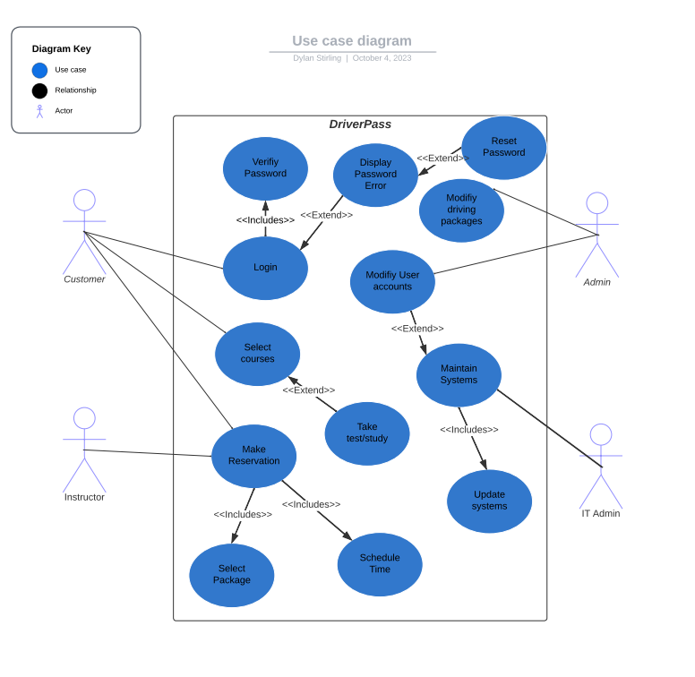

### UML Activity Diagram 1

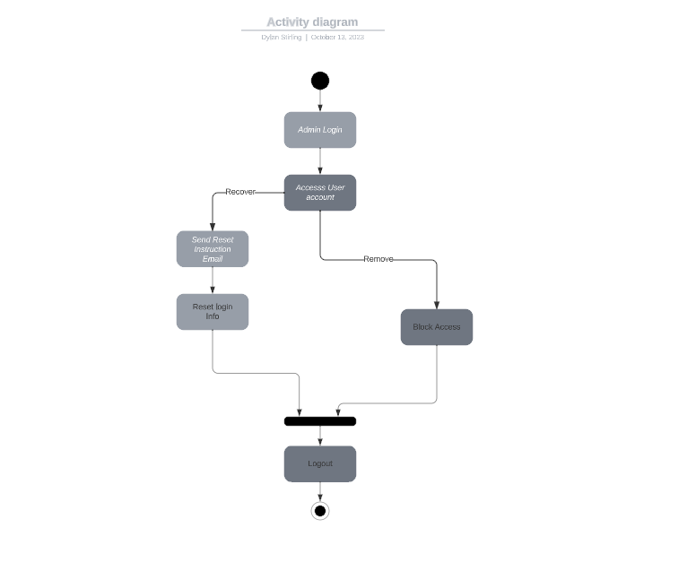

### UML Activity Diagram 2

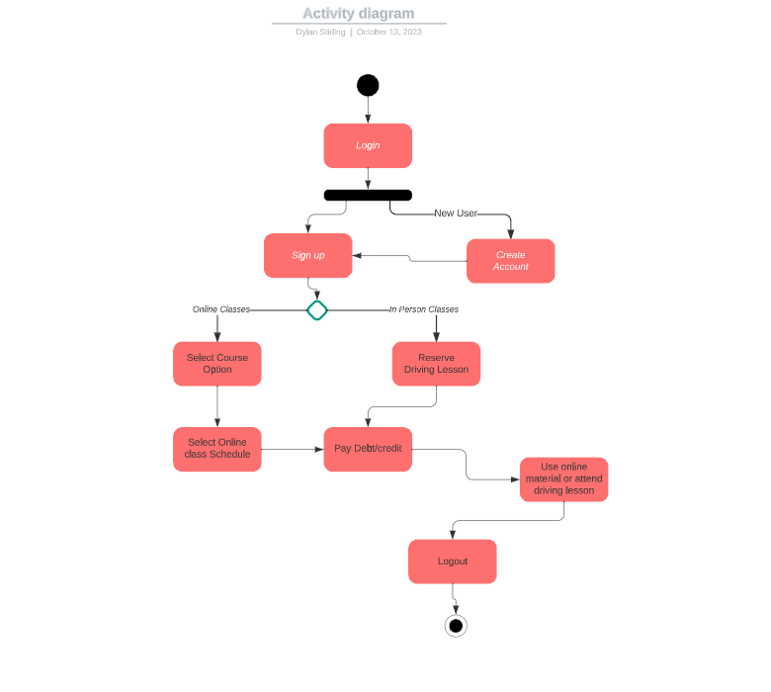

### UML Sequence Diagram

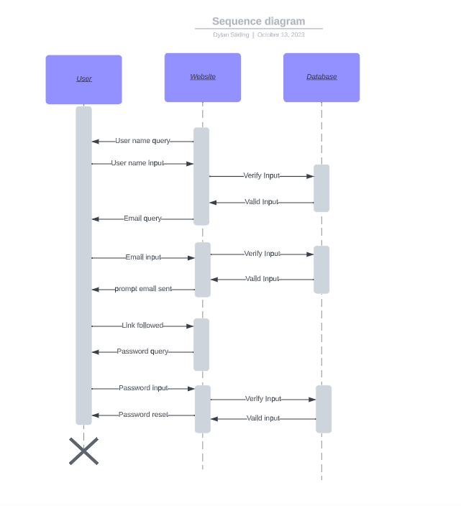

### UML Class Diagram

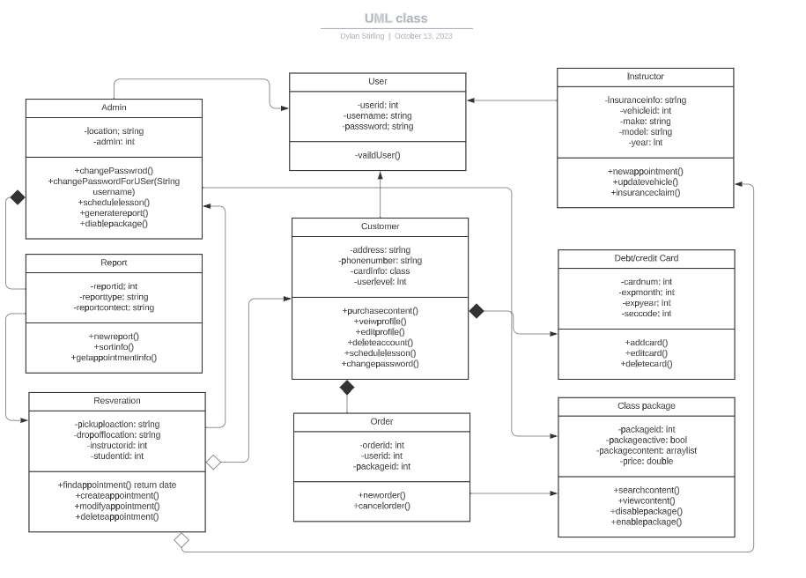

## Technical Requirements

* Hardware Requirements:
  + Server Hardware:
    - Robust web servers to host the application.
    - Sufficient processing power and memory to handle concurrent user interactions.
    - Redundancy and failover capabilities to ensure high availability.
  + Database Server:
    - A dedicated database server to store user data, reservations, course information, and instructor details.
    - Adequate storage space to handle data storage requirements.
    - Backup and recovery systems to safeguard data.
  + User Devices:
    - User devices such as desktop computers and mobile devices with internet connectivity.
    - Compatibility with a wide range of devices to ensure accessibility.
    - Software Requirements:
    - Web Development Frameworks:
    - Modern web development frameworks for building the front-end interface.
    - Integration with back-end components.
  + Database Management System (DBMS):
    - A relational database management system to store and retrieve user data, reservations, courses, and instructor information.
    - Efficient query processing and data management.
  + Security Tools:
    - Implementation of security tools and protocols for data encryption, user authentication, and authorization (e.g., HTTPS).
    - Security updates and patches to protect against vulnerabilities.
  + Integrated Development Environments (IDEs):
    - Development IDEs for programmers to create and maintain the system code.